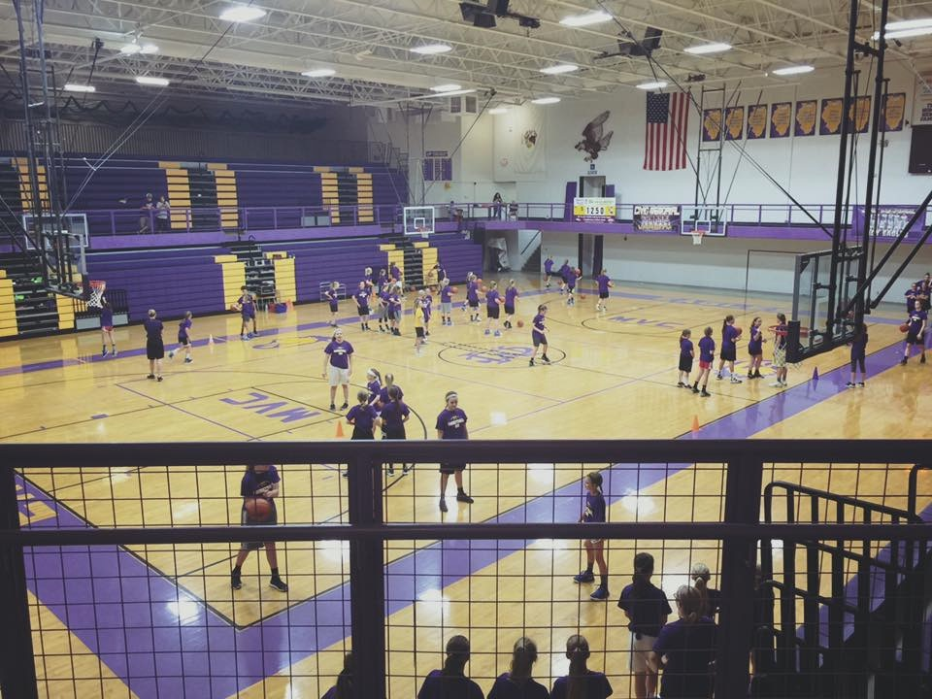
2018 LADY EAGLE
BASKETBALL CAMP

“Whatever you do, do it with passion or don’t do it.”
Camp Dates:
May 29th- June 1st
*Incoming Grades
3rd, 4th, & 5th - 1:00-3:00pm daily
6th, 7th, & 8th - 3:30-5:30 pm daily

Name______________________________________________
$50 Registration Deadline: Monday, May 15th --$60 after May 15th
Mail registration and check to:
Jonathan Denney
227 Poplar St. Cottage Hills, IL 62018
Phone: (618) 259-1019/(618) 978-9133

Incoming Grade: 3rd 4th 5th 6th 7th 8th

T-Shirt size: YM YL AS AM AL AXL

Parent/Guardian____________________________________

Home Phone _______________________________________

Emergency Contact __________________________________

Street _____________________________________________

City ______________________________________________

Please read below: My child promises to abide by the rules set forth by Civic Memorial High School and the Lady Eagle Coaching Staff. If my child does not follow the rules the money is forfeited as is the tenure of the camp. I give permission for my child to be treated by the appropriate medical personnel for any injury / accident while attending camp, and will not hold Civic Memorial High School or any member of the camp staff liable as a result of this participation.
Camp Includes:
*Individualized instruction
*T-shirt
*Hustle Awards
*Contests
C

Signature____________________________

Date________________________________

